MobileTestingScenario_runTestScenario_Instance3_05-Apr-2016_08-56-55_AM_Staging_Page_Navigation.png

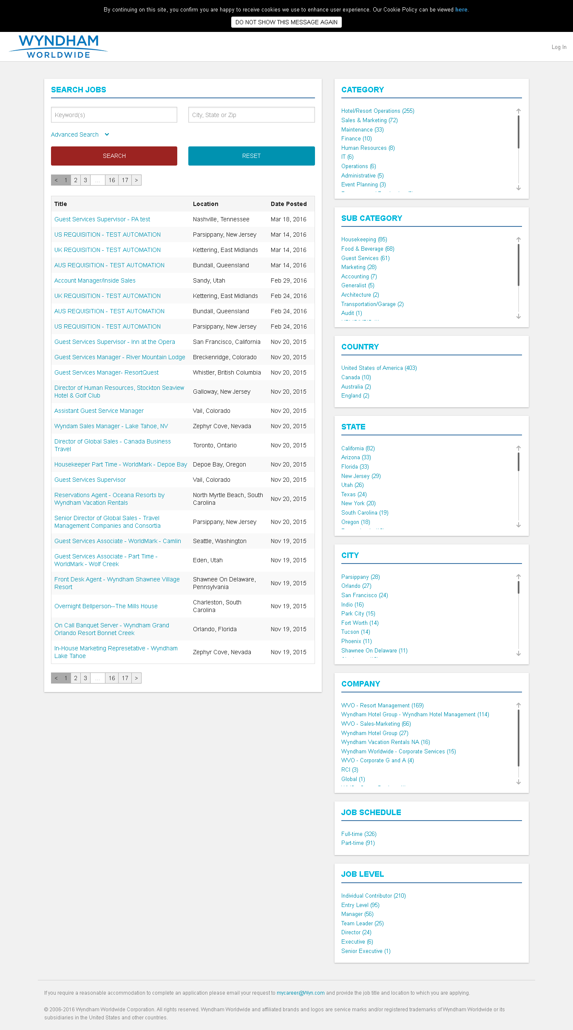

MobileTestingScenario_runTestScenario_Instance3_05-Apr-2016_08-57-40_AM_Create_Account.png

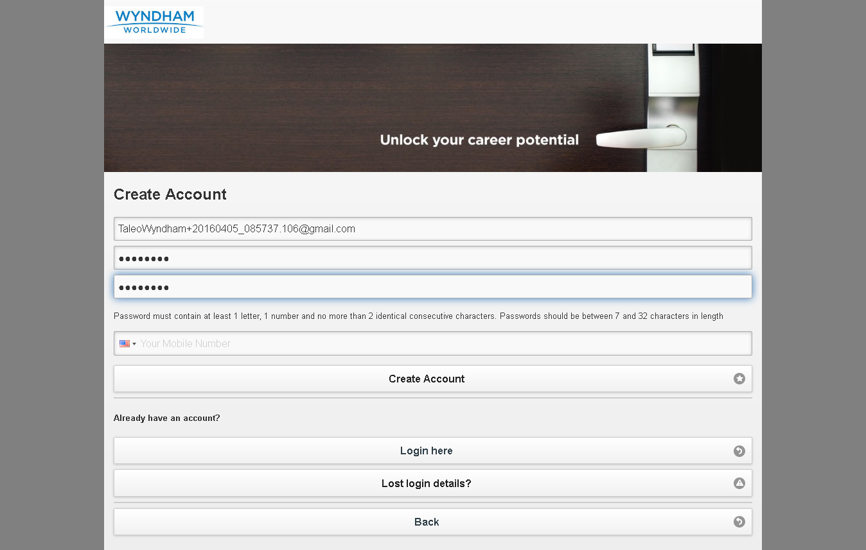

MobileTestingScenario_runTestScenario_Instance3_05-Apr-2016_08-57-58_AM_Continue.png

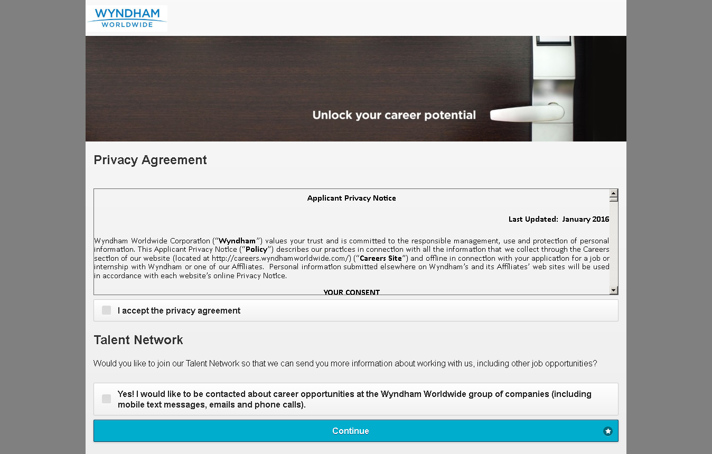

MobileTestingScenario_runTestScenario_Instance3_05-Apr-2016_08-57-58_AM_Create_Account.png



MobileTestingScenario_runTestScenario_Instance3_05-Apr-2016_08-58-05_AM_privacyAgreement.png

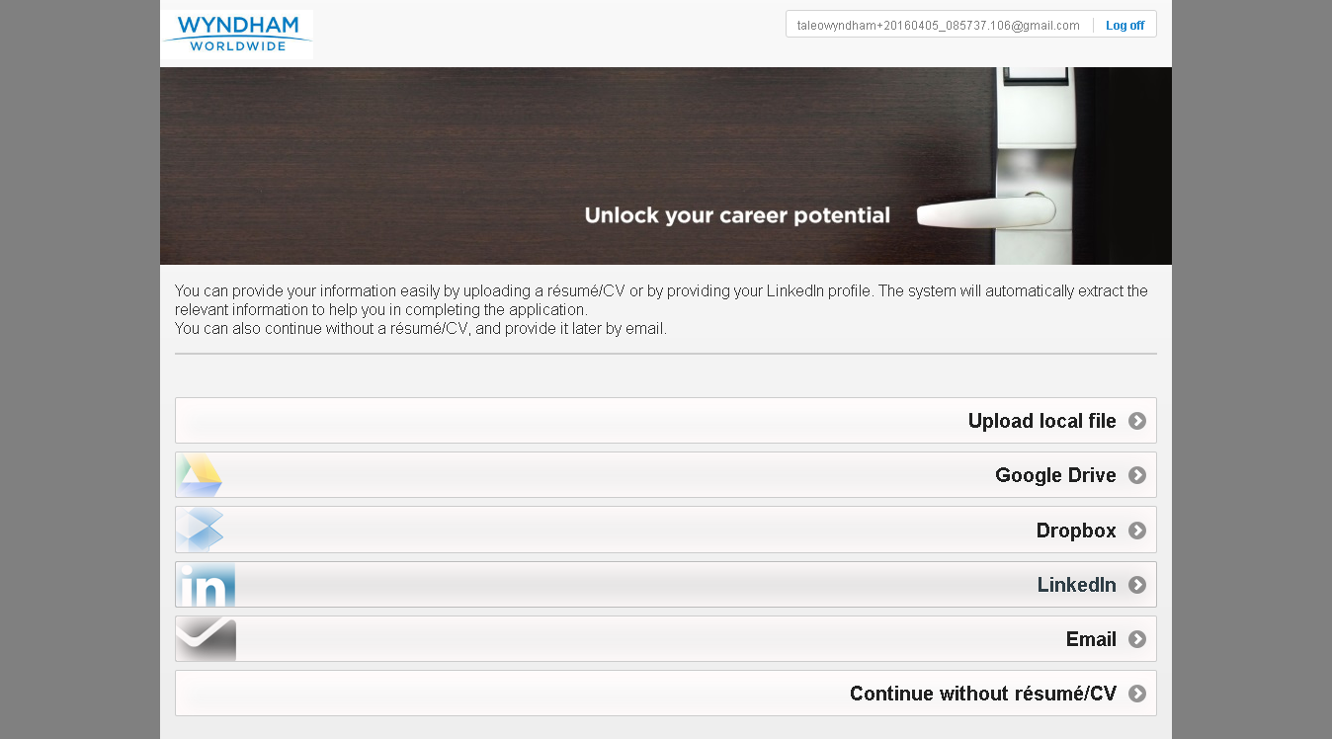

MobileTestingScenario_runTestScenario_Instance3_05-Apr-2016_08-58-05_AM_Resume_Option.png



MobileTestingScenario_runTestScenario_Instance3_05-Apr-2016_08-58-18_AM_Dropbox_Option.png

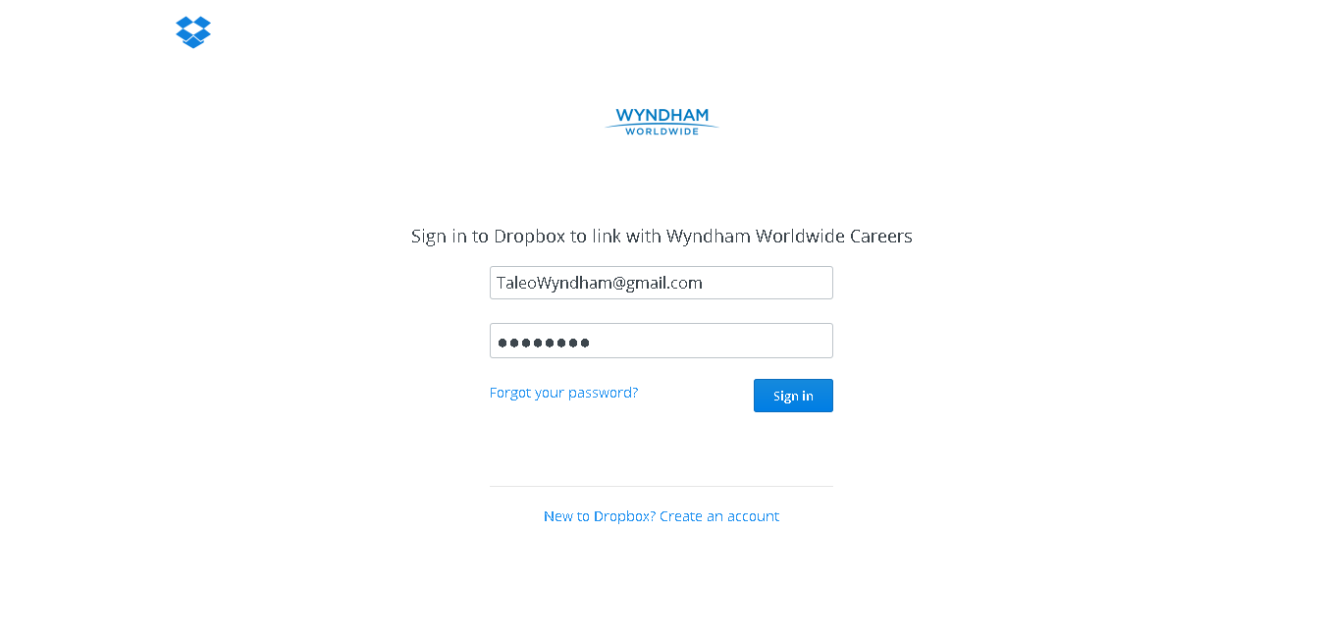

MobileTestingScenario_runTestScenario_Instance3_05-Apr-2016_08-58-32_AM_Dropbox_Option.png

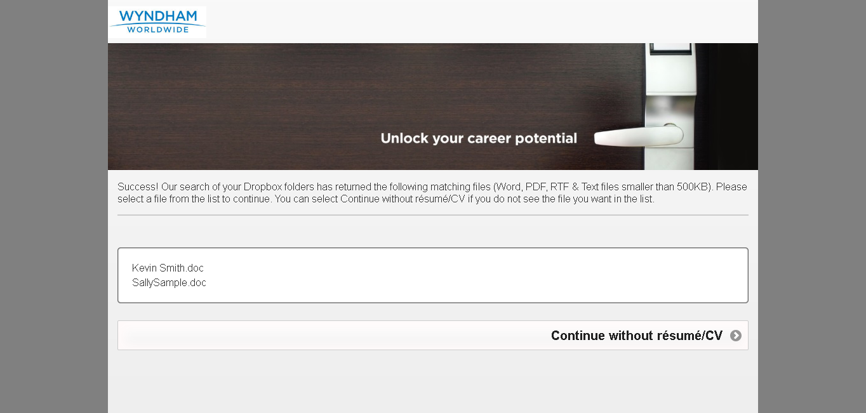

MobileTestingScenario_runTestScenario_Instance3_05-Apr-2016_08-58-42_AM_Dropbox_Option.png

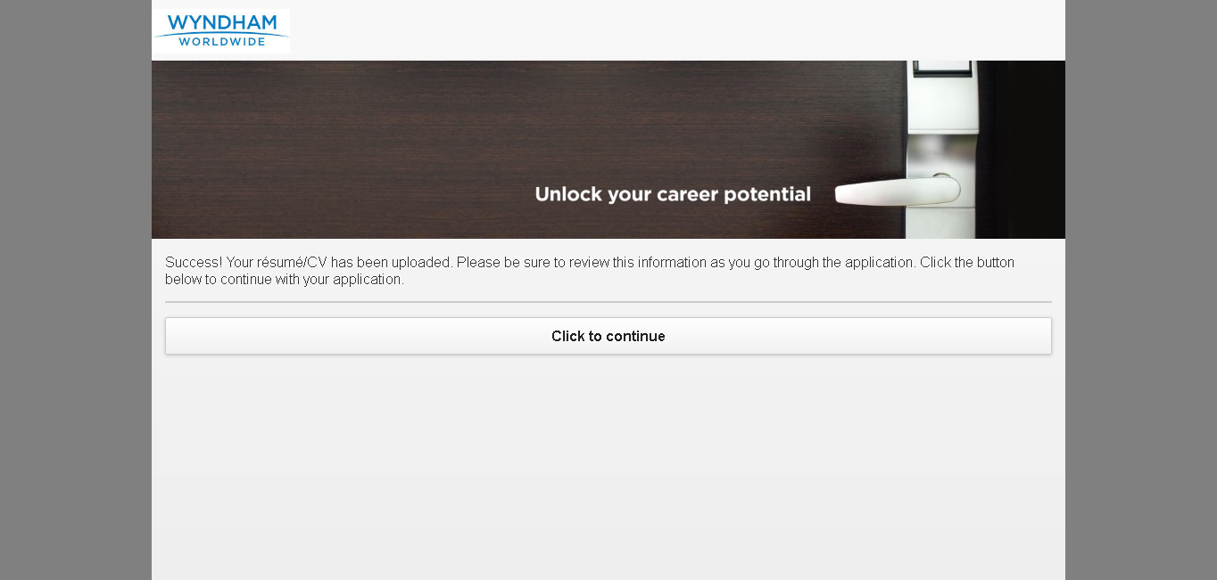

MobileTestingScenario_runTestScenario_Instance3_05-Apr-2016_08-59-25_AM_Tell_us_about_yourself.png

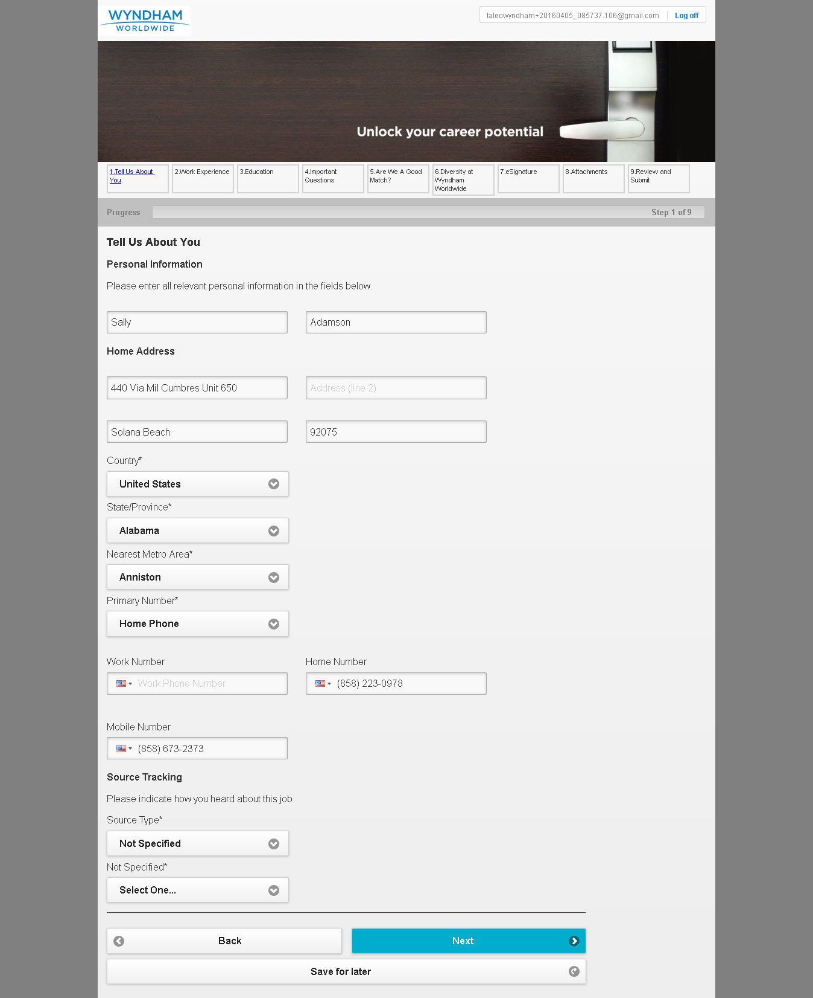

MobileTestingScenario_runTestScenario_Instance3_05-Apr-2016_08-59-36_AM_Tell_us_about_yourself.png

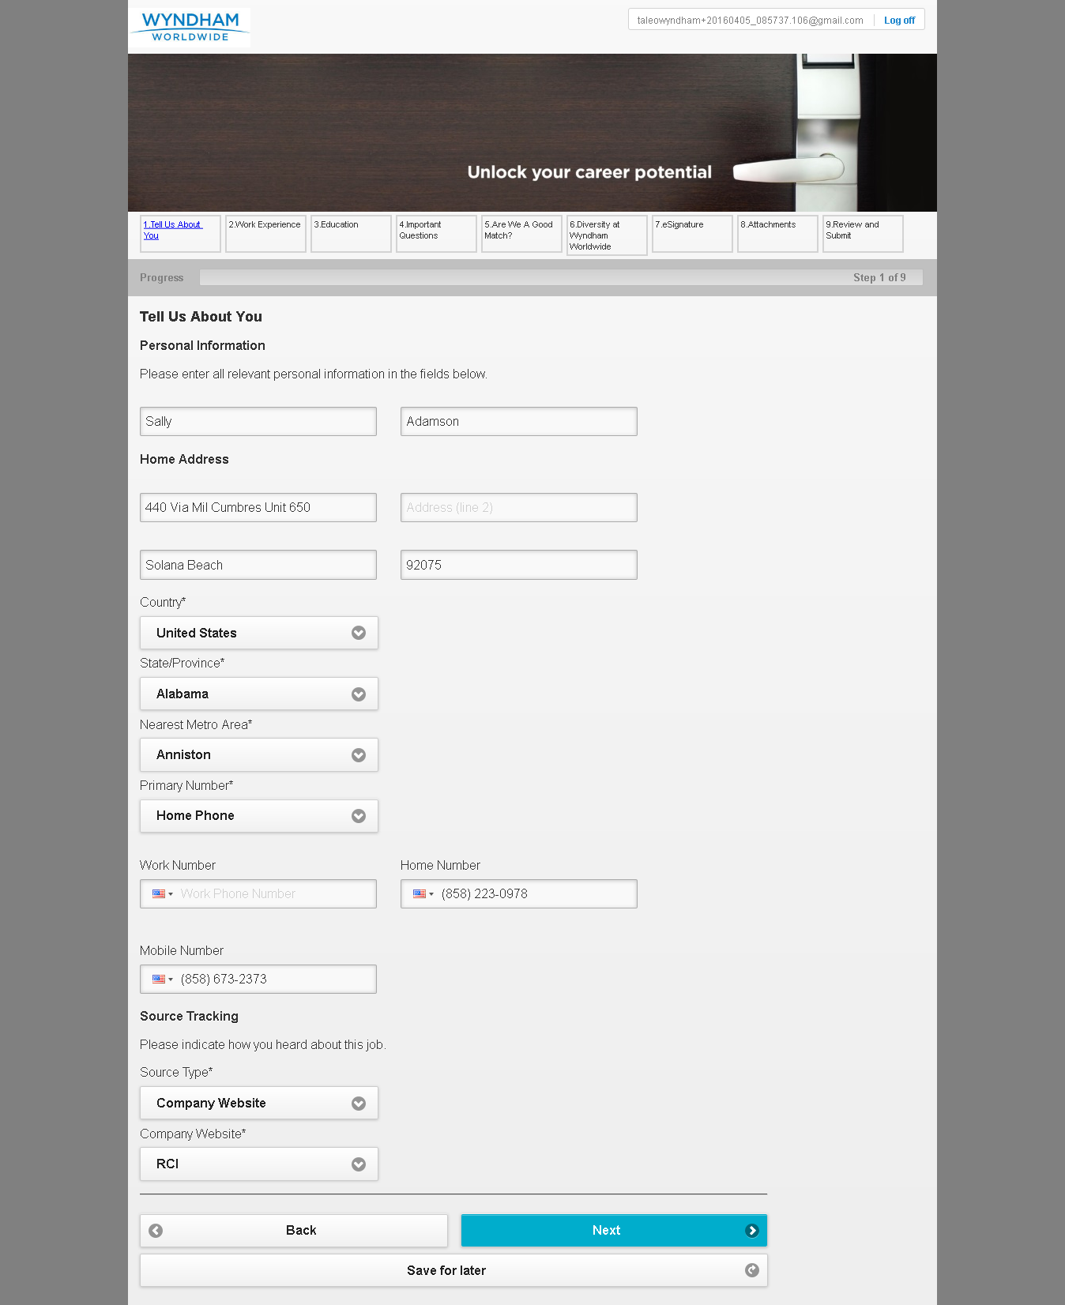

MobileTestingScenario_runTestScenario_Instance3_05-Apr-2016_08-59-50_AM_Work_Experience.png

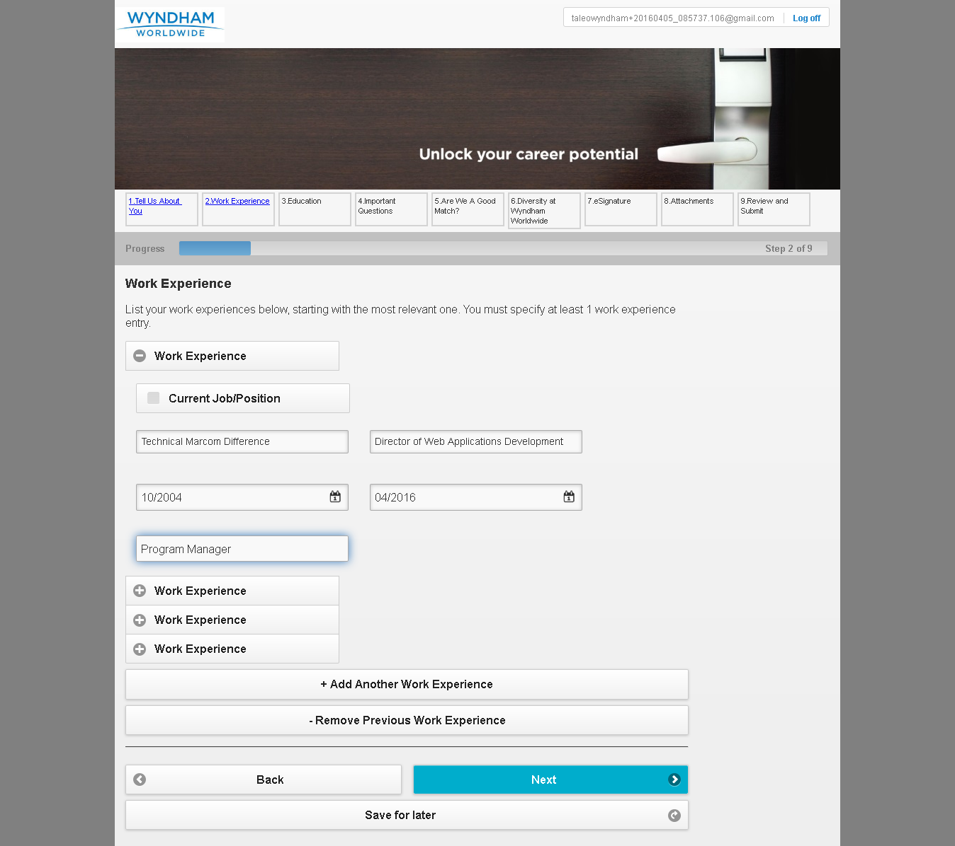

MobileTestingScenario_runTestScenario_Instance3_05-Apr-2016_09-00-06_AM_Education.png

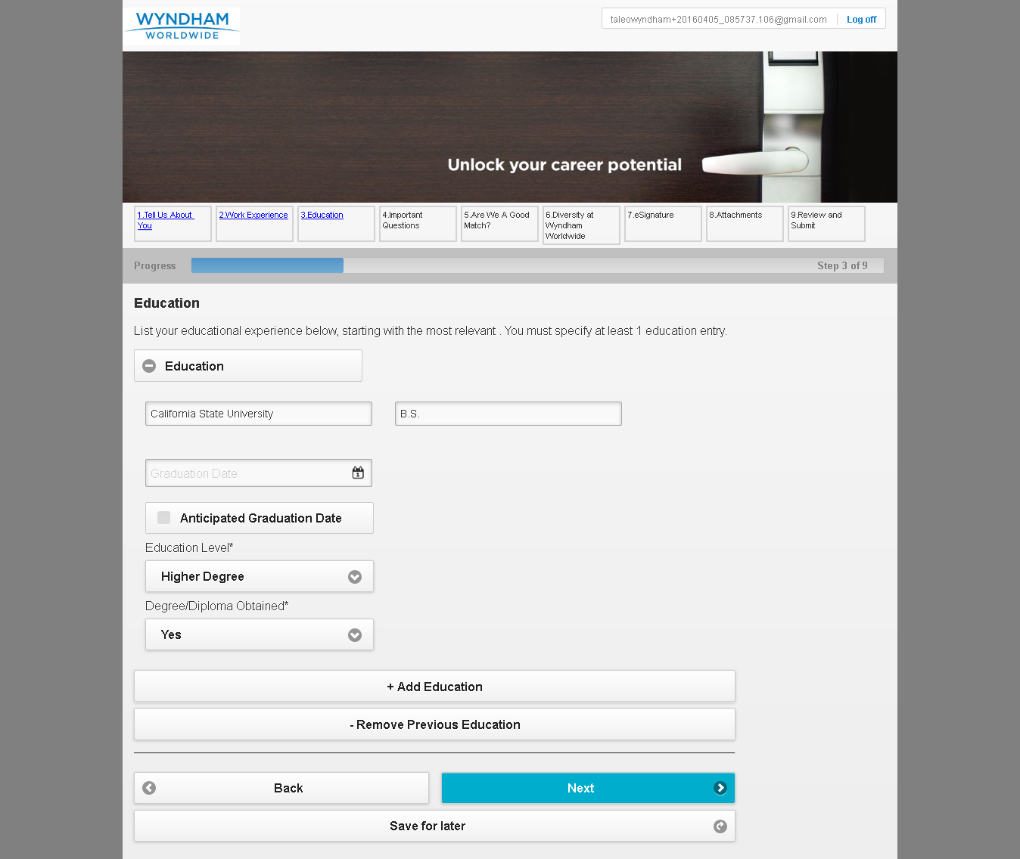

MobileTestingScenario_runTestScenario_Instance3_05-Apr-2016_09-00-14_AM_Questions.png

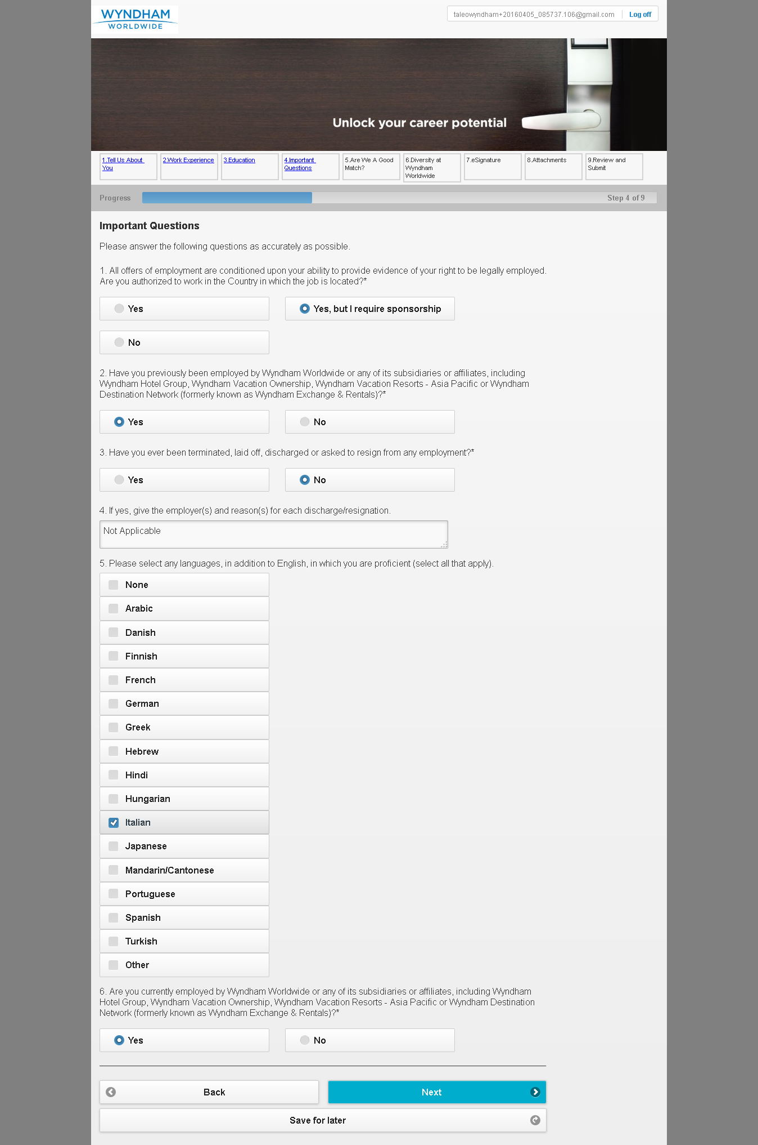

MobileTestingScenario_runTestScenario_Instance3_05-Apr-2016_09-00-24_AM_Are_we_good_Match.png

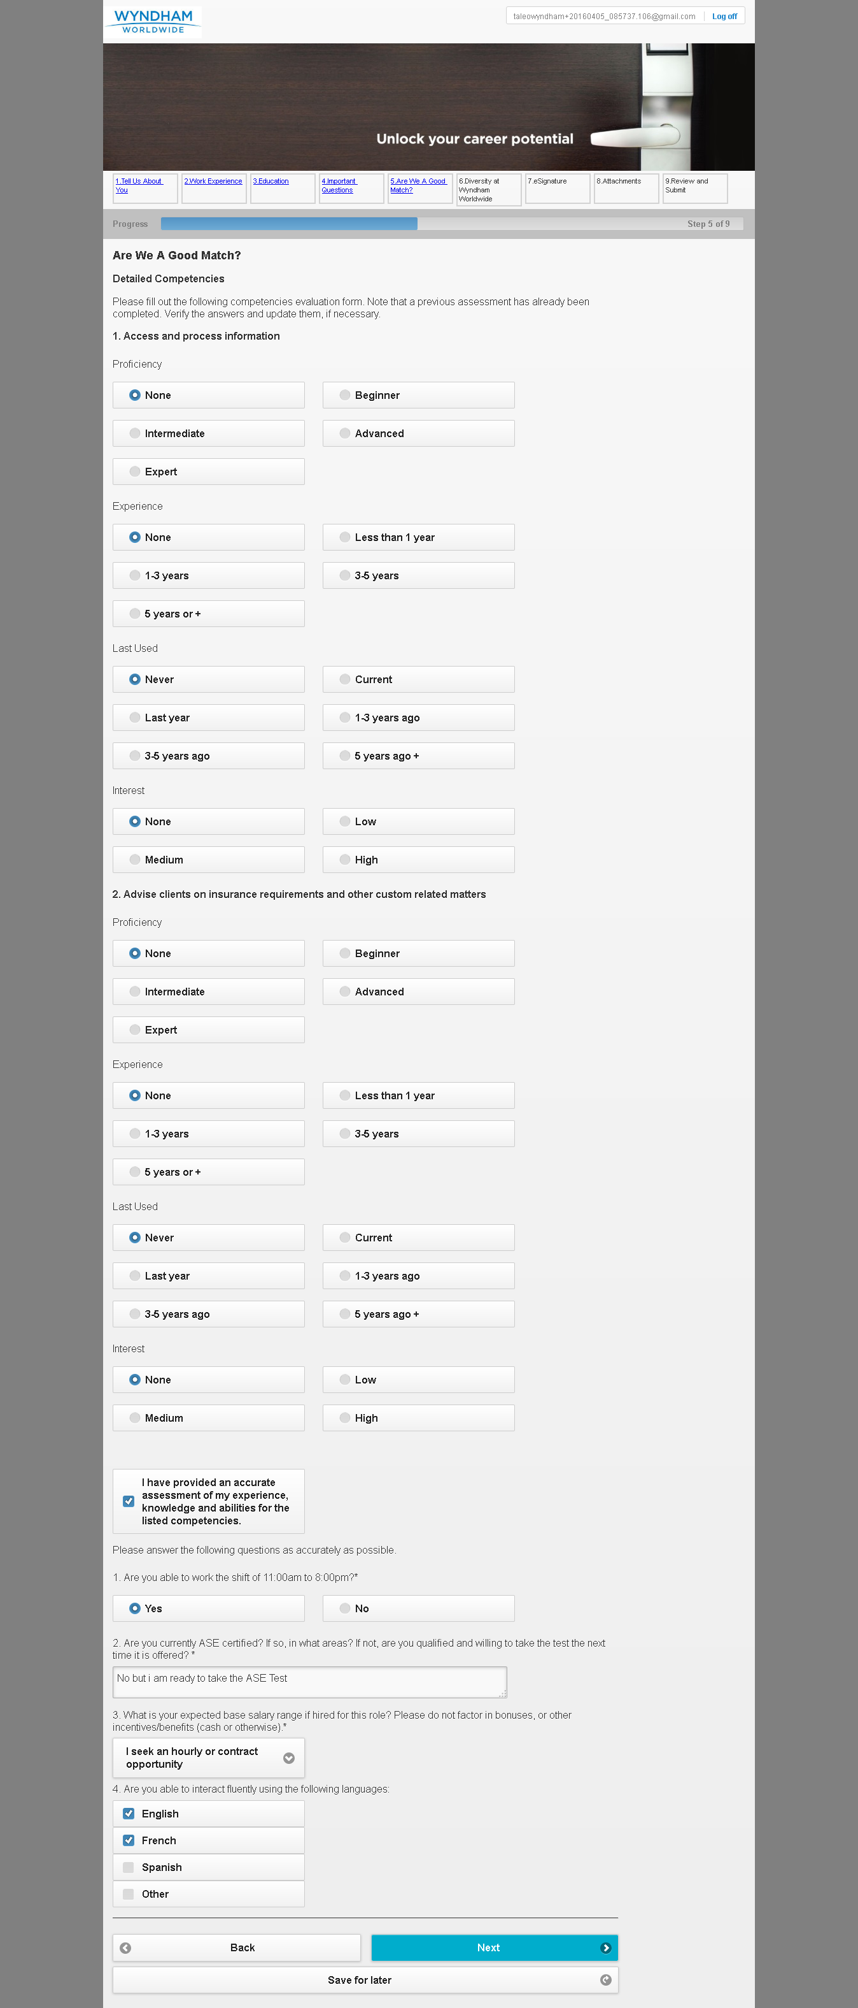

MobileTestingScenario_runTestScenario_Instance3_05-Apr-2016_09-00-47_AM_Diversity.png

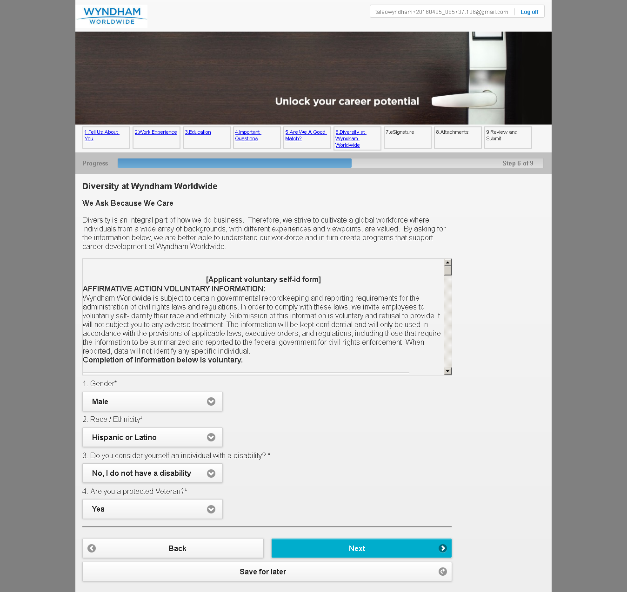

MobileTestingScenario_runTestScenario_Instance3_05-Apr-2016_09-00-55_AM_eSignature.png

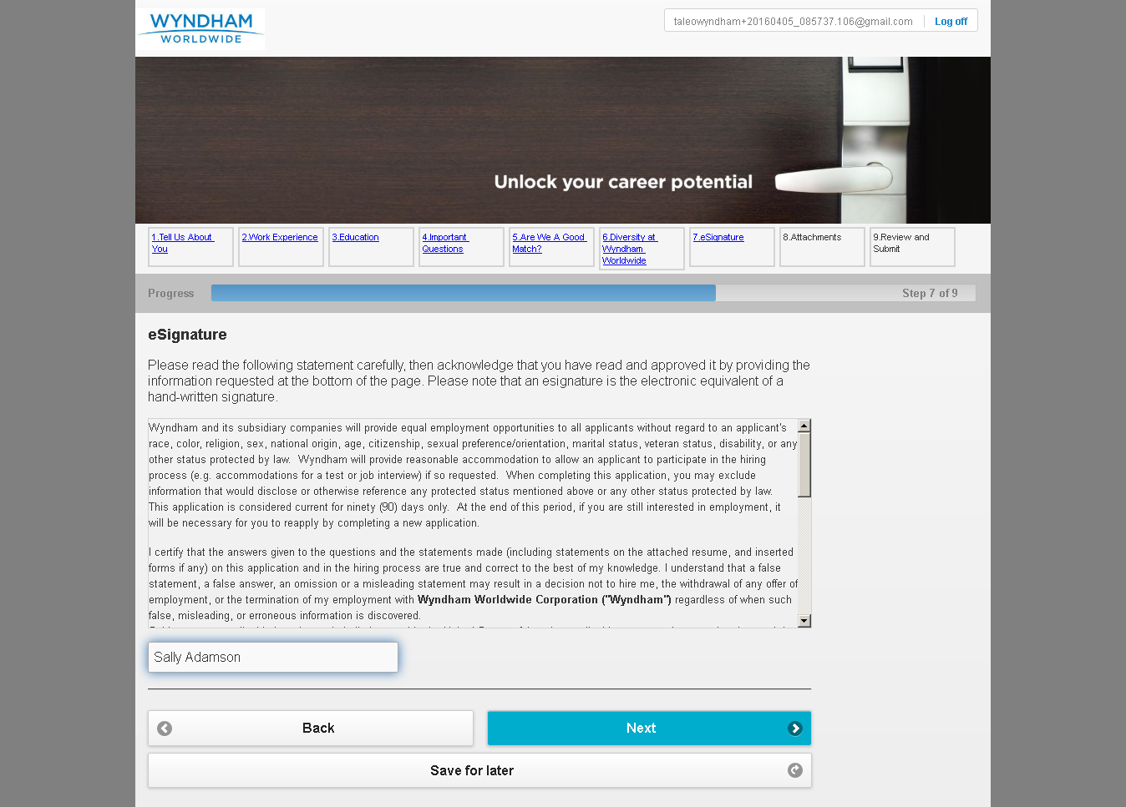

MobileTestingScenario_runTestScenario_Instance3_05-Apr-2016_09-01-06_AM_Attachment.png

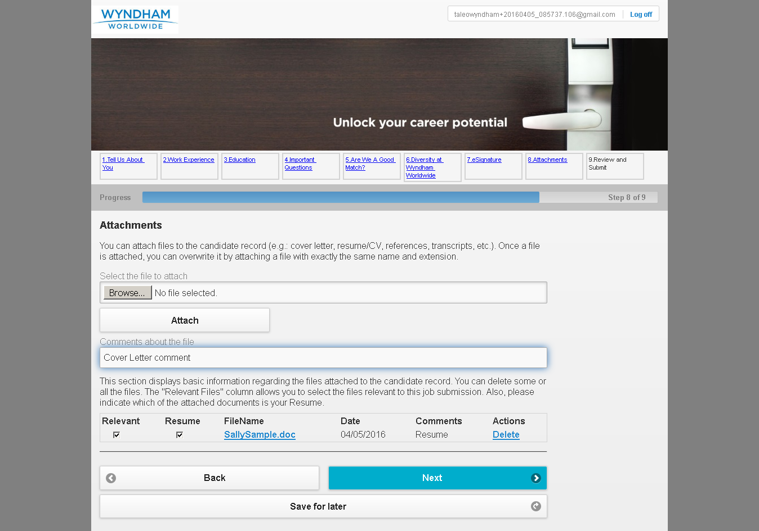

MobileTestingScenario_runTestScenario_Instance3_05-Apr-2016_09-01-16_AM_Review_and_Submit.png

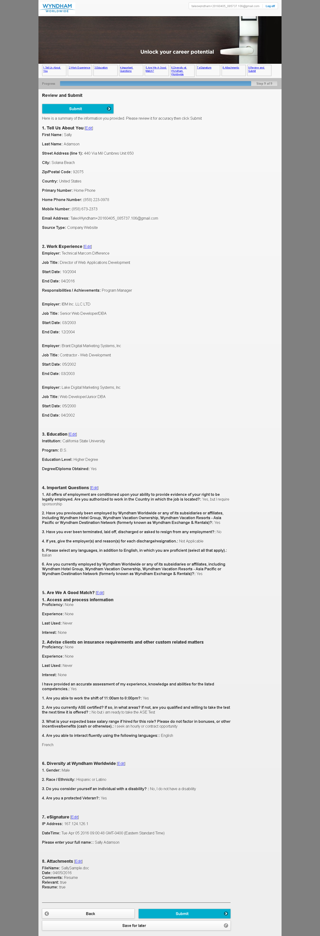

MobileTestingScenario_runTestScenario_Instance3_05-Apr-2016_09-01-27_AM_Application_Completed.png

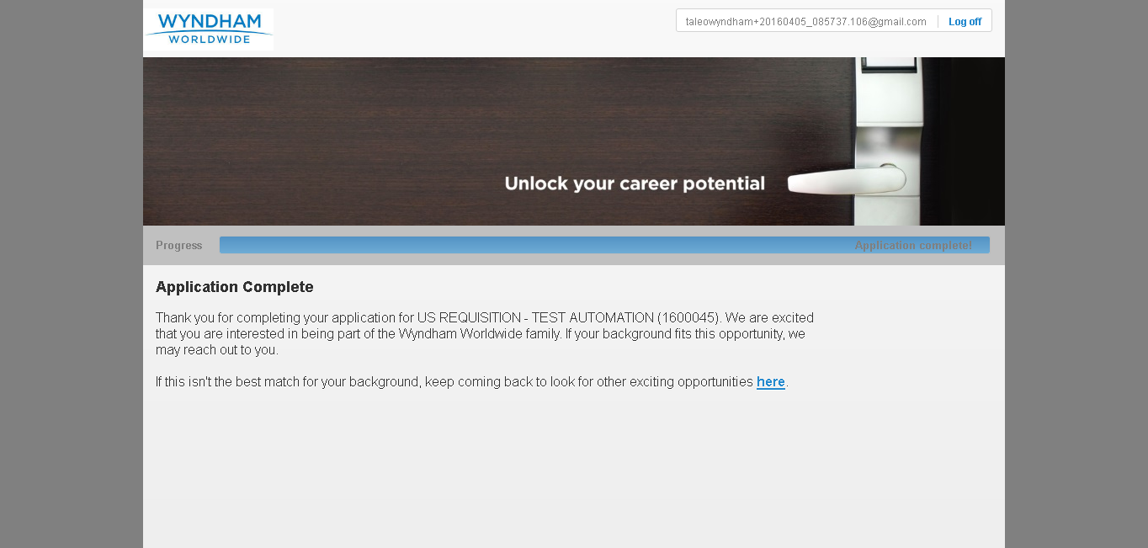

MobileTestingScenario_runTestScenario_Instance3_05-Apr-2016_09-01-41_AM_CRM_Loop_Validation.png

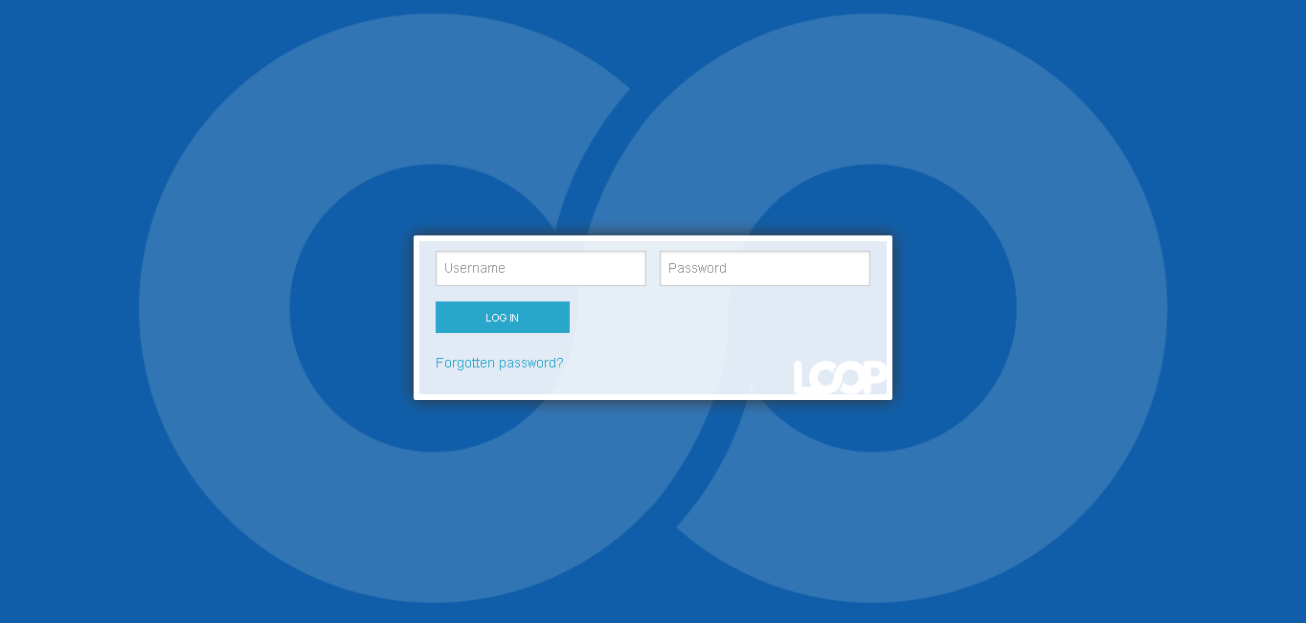

MobileTestingScenario_runTestScenario_Instance3_05-Apr-2016_09-01-50_AM_CRM_Loop_Validation.png

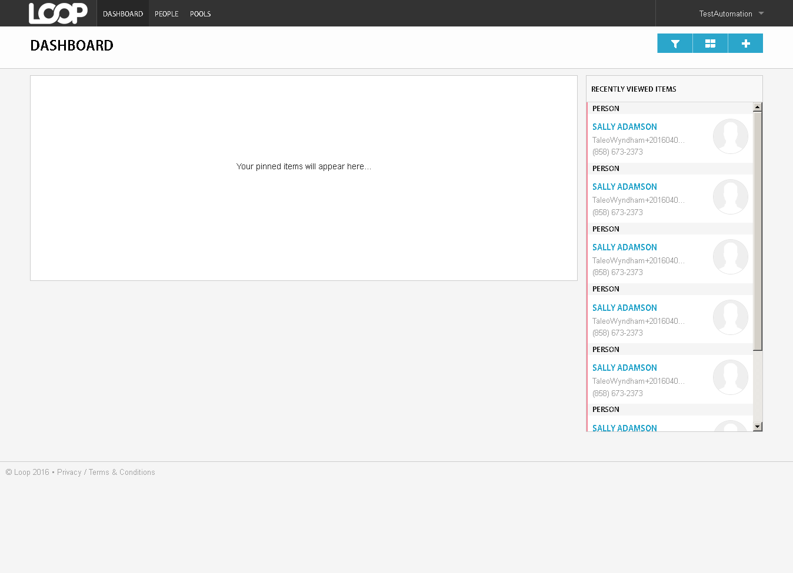

MobileTestingScenario_runTestScenario_Instance3_05-Apr-2016_09-02-05_AM_CRM_Loop_Validation.png

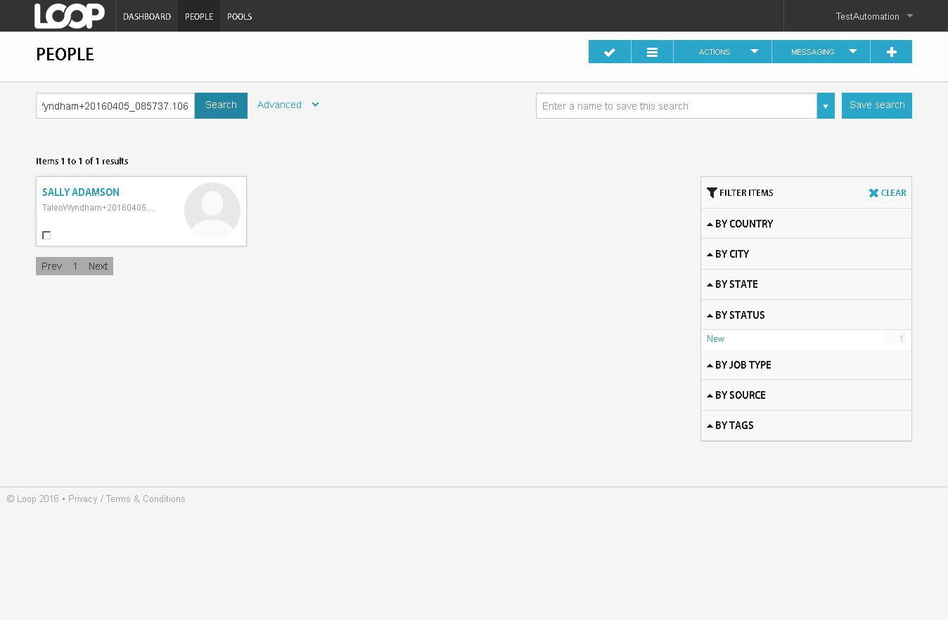

MobileTestingScenario_runTestScenario_Instance3_05-Apr-2016_09-02-10_AM_CRM_Loop_Validation.png

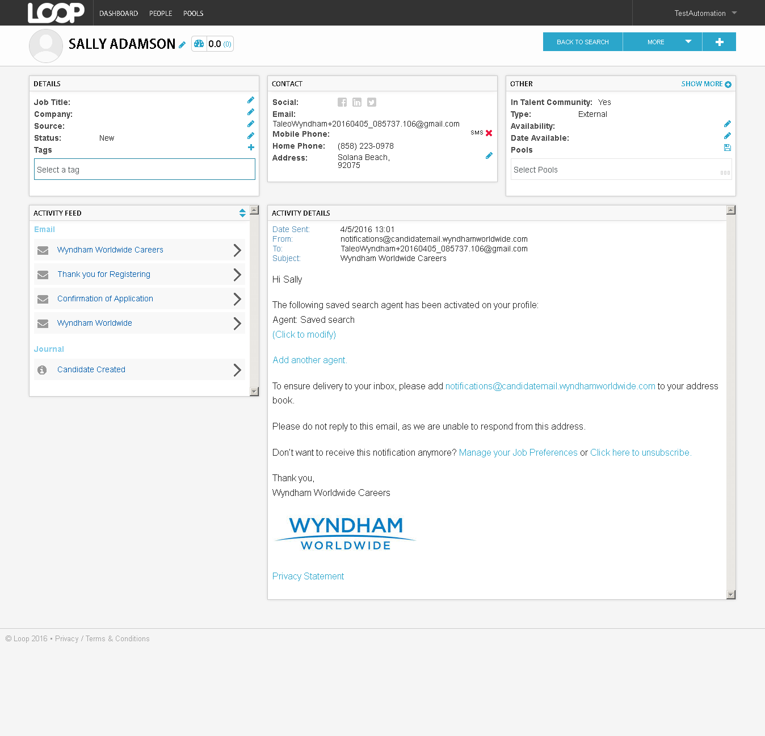

MobileTestingScenario_runTestScenario_Instance3_05-Apr-2016_09-02-16_AM_CRM_Loop_Validation.png

